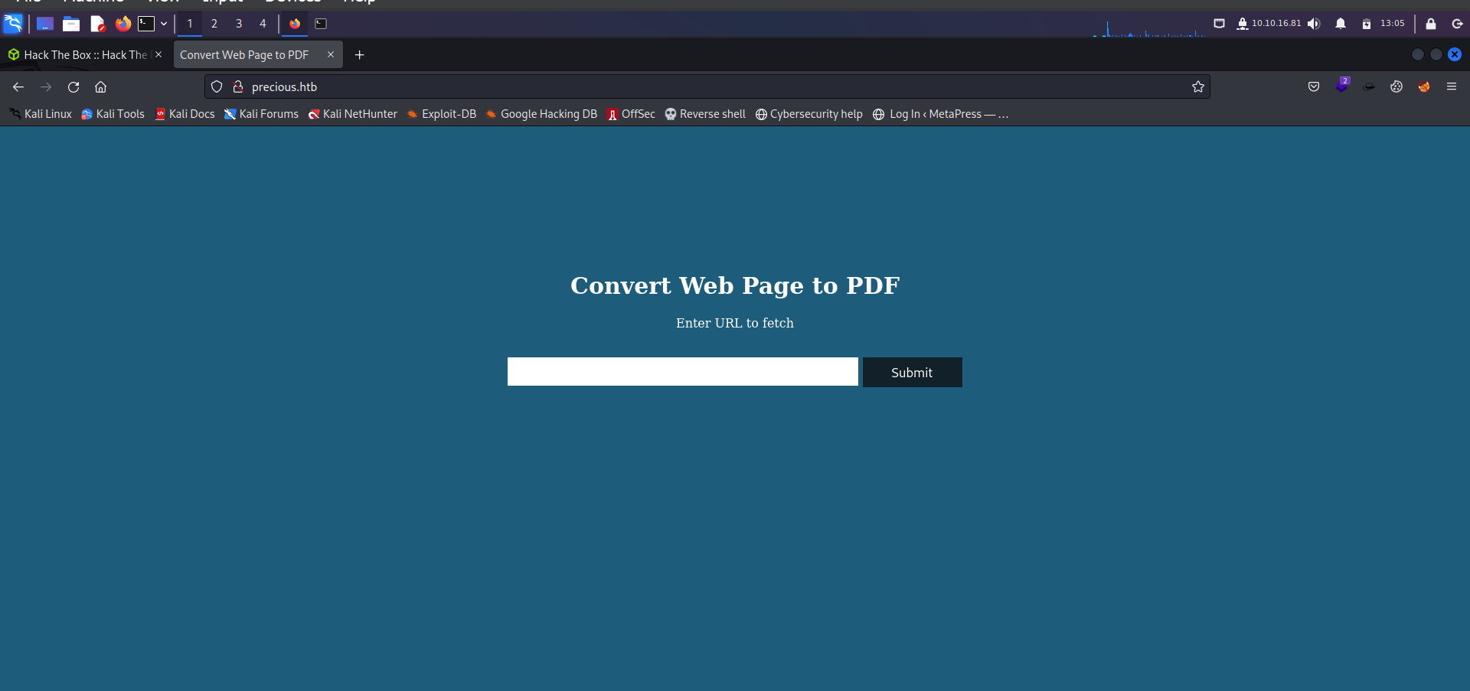**Precious HTB**

Here, in this above picture this site is a hackthebox Easy lab which we can access through putting the ip in the /etc/host. So, let’s try to exploit it.

Here, in this site after attempting all the bug impacts that can be found but still, there is no any impact in this site. So, let’s try to take the connection through

**Python3 -m http.server 80**

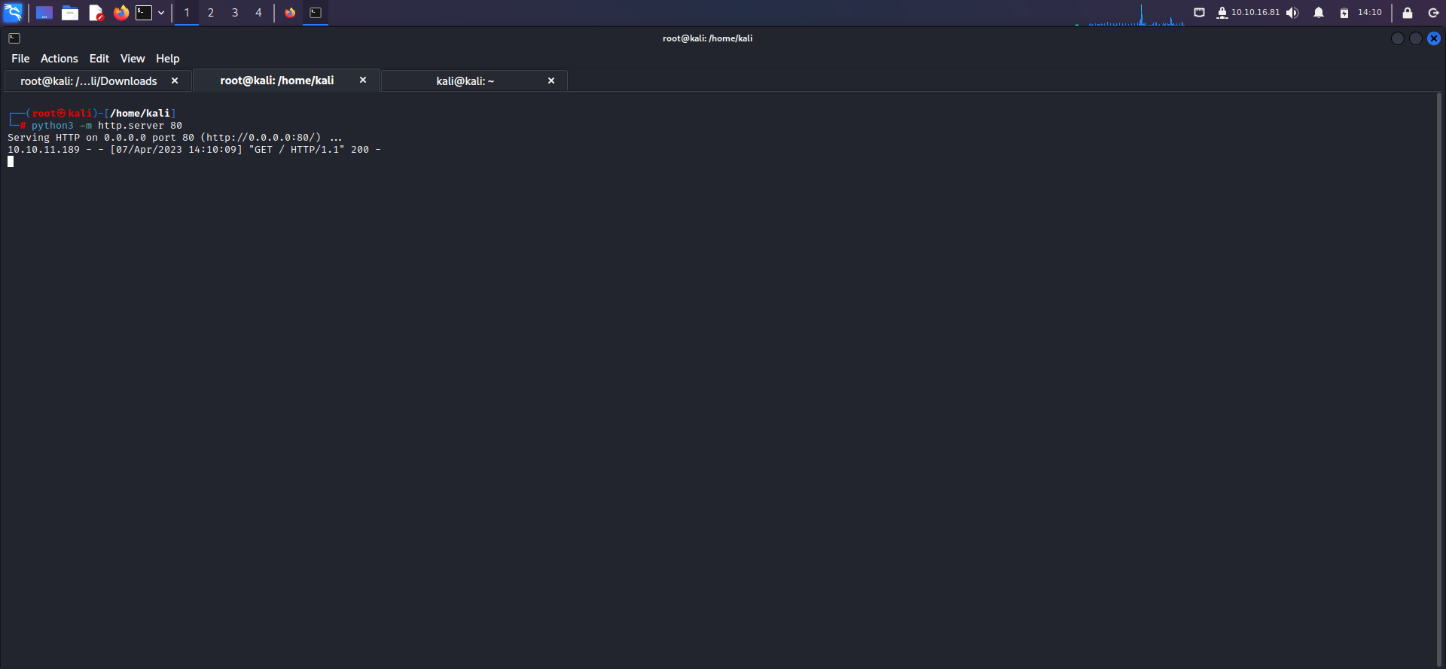

Here, in this above picture we’ve tried to take the connection from the website so, let’s put the ip at the website.

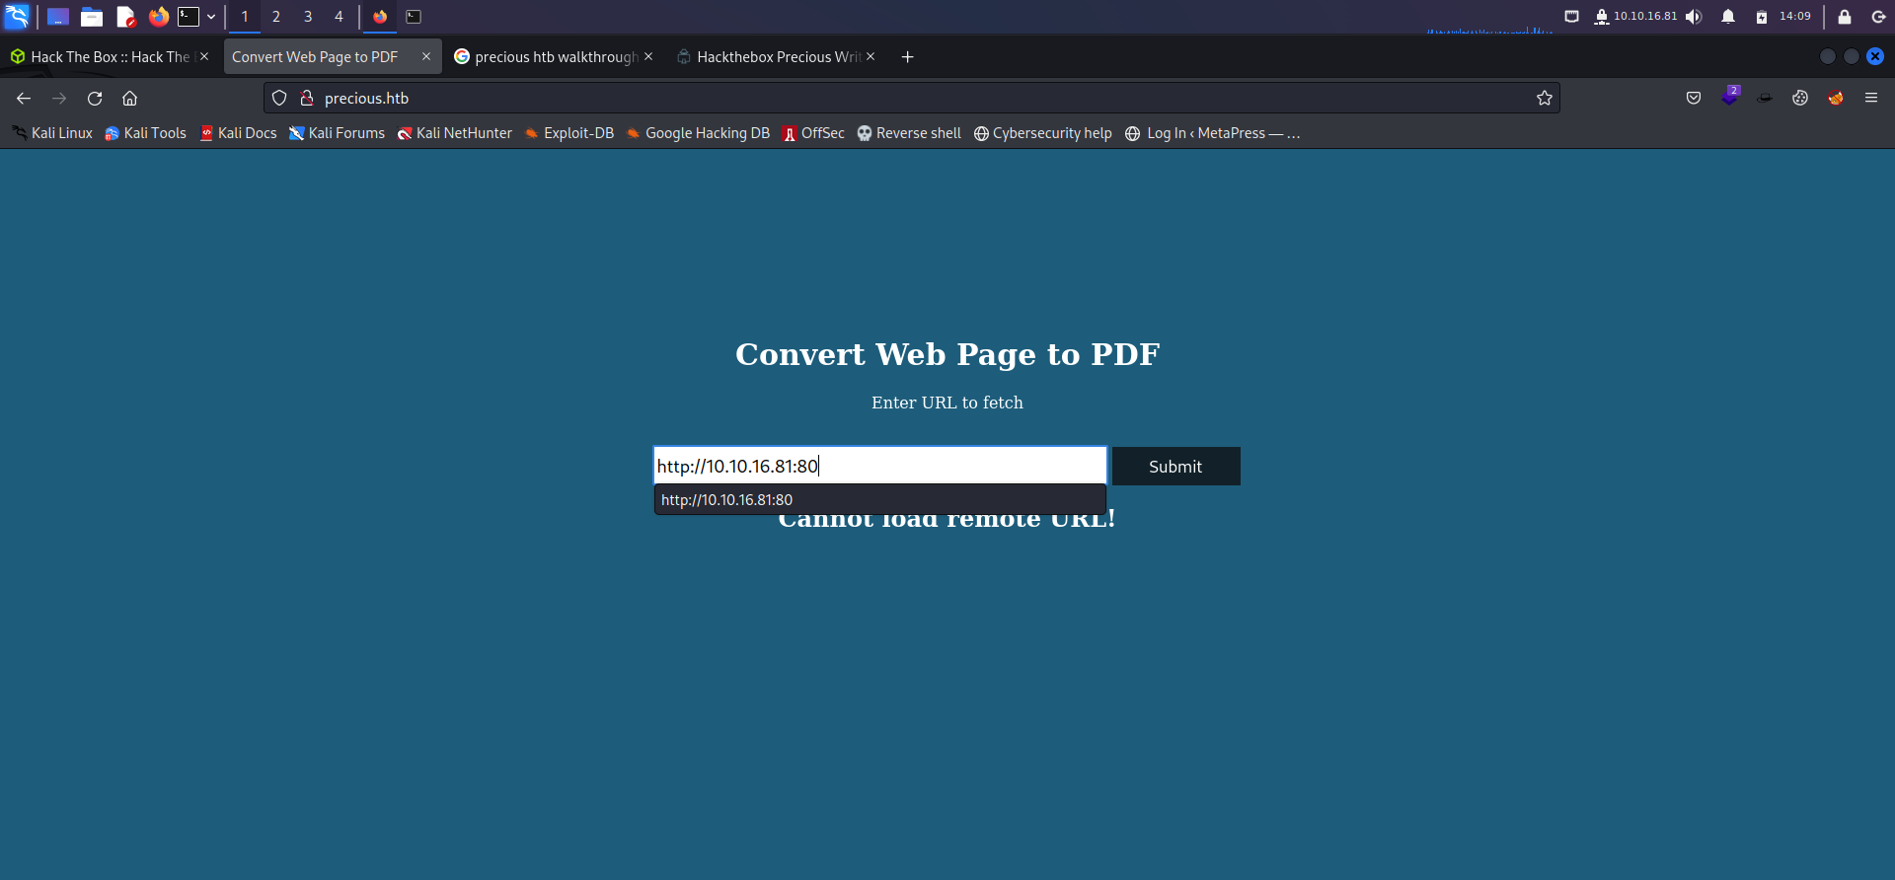

Here, in this above picture we’ve putted the ip in the search box. And let’s try to take the connection of the ip if it takes connection it will show the directory of our linux.

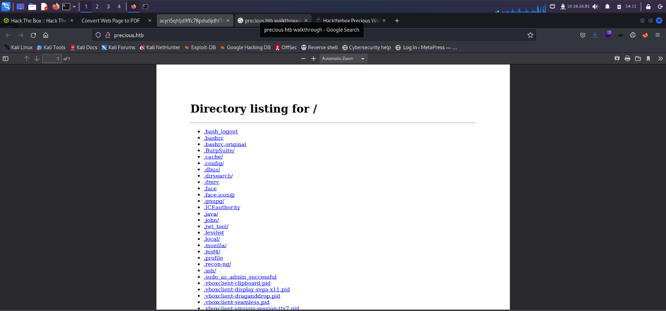

Here, after getting the connection we’ve our directory which is shown as a pdf in the website, so let’s download it and exploit it’s version.

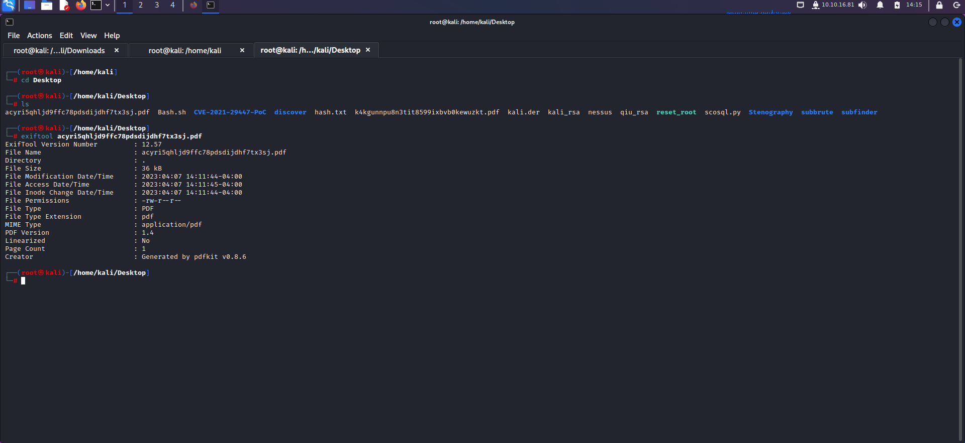

Here, in this above picture we’ve found that the pdf is generated by the pdfkit v0.8.6 which Is vulnerable let’s search this exploit in the google.